***Outputs of Online Quiz Application***

Creating an online quiz application

Below are some of the snapshots of the end application:

Registration Page

Before taking a quiz, a user have to first register and login. To register one can directly click on the register menu or a link to registration page is provided on the login page to create an account.

Login Page

When a user clicks, an exam user is directly redirected  to the login page, if the user is not logged in.

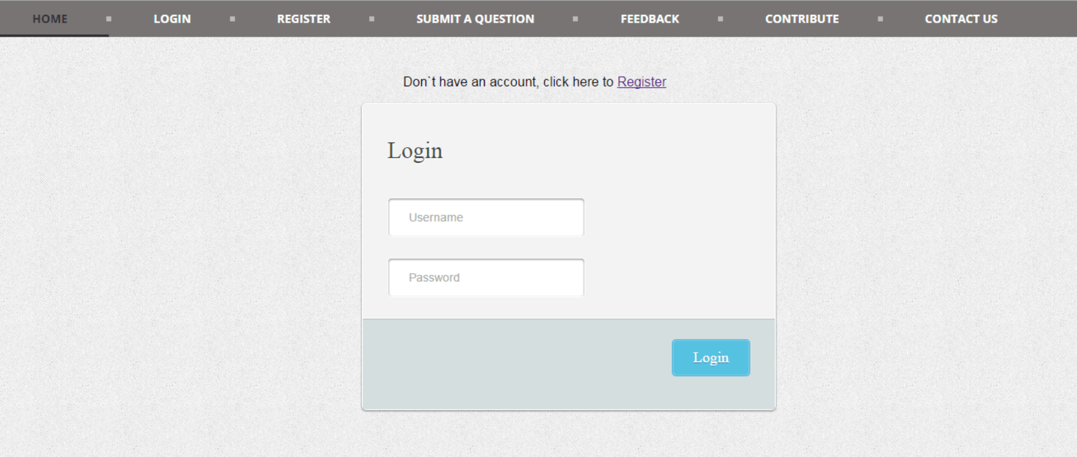

## User Home Page

Home page is the landing page of the application from where a user can take any quiz by clicking on the quiz. On the home page, if the user is logged in his name is also shown and a logout link is provided to logout from the application.



## Quiz Screens

On starting a quiz, a user is presented with the first question of the quiz with the next and finish button. Note that the previous button is not shown when the user is on first question and next button is not shown when the user is in the last question.

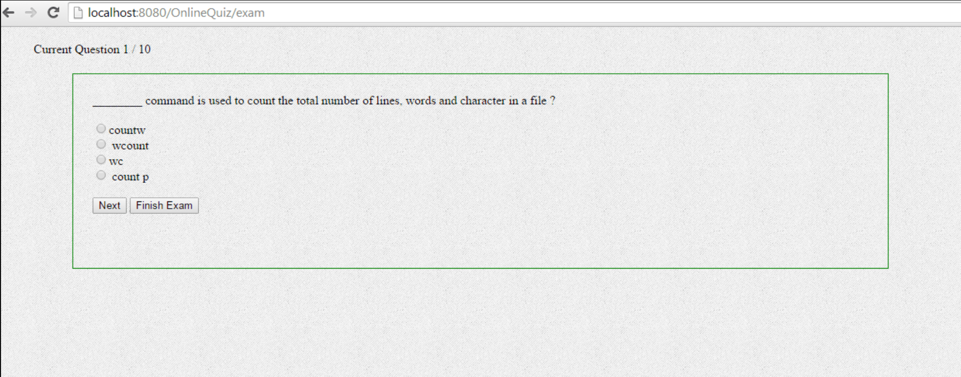

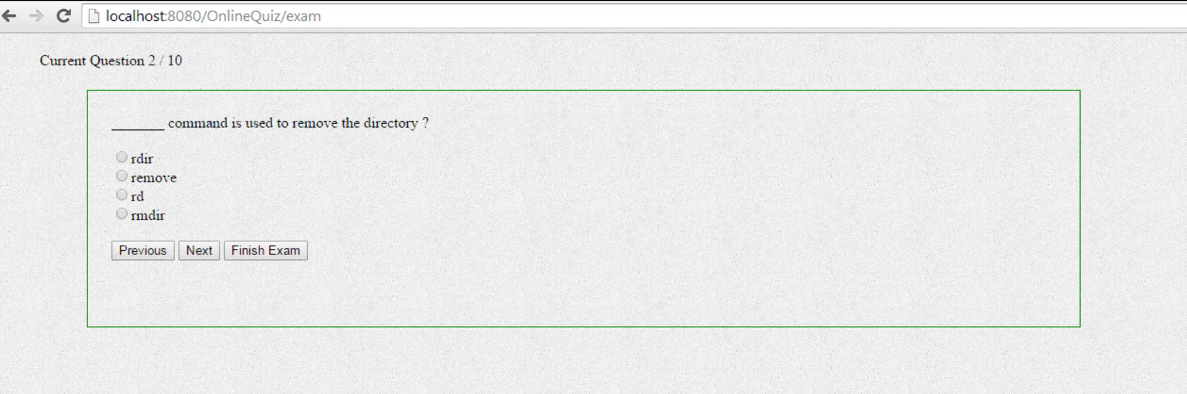

## Quiz Result

After clicking on the finish button the user is presented with exam results, showing the name of quiz; time when the quiz was started and the number of questions that the user answered correctly.

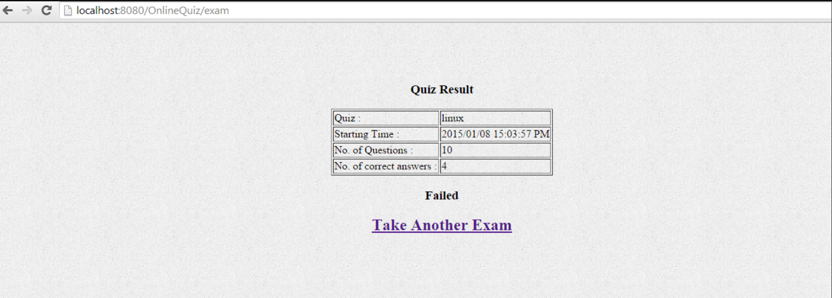

Below is the snapshot of the project structure in Eclipse IDE.

## Project Structure

